**POV Hunting Robots For An Online Auction**

**Problem Statement**

Human bidders on the site are getting increasingly dissatisfied with their inability to win bids when compared to their software-controlled competitors. As a result, the usage among the site's core customers is declining.



**Automated robots generate much of the bidding activity on electronic bidding markets and online auction platforms. As a result, human bidders on the site are getting increasingly dissatisfied with their inability to win bids when compared to their software-controlled competitors. This has led to a decline in usage among the site's core customers. Bidding robots such as “BidRobot” are pieces of software that are configured by the user to follow any number of auctions on different auction sites simultaneously, bidding in place of the user according to predefined settings and preferences.**

**Humans are not capable of attending to and monitoring auctions with the same capacity as a computer, which can make complex bidding decisions in split-second time and can follow an auction with nonstop, undivided attention.**

**How Does Bidding work?**

There are the steps involved in the bidding process

* Communication with the seller during the auction
* Duration of the auction
* Dynamic Pricing

* Product Quality
* Distribution Network

 Here are some factors that affect the business

**Communication with the seller during the auction**

Communicating the qualities of the product being sold is another important factor

**Duration of the auction**

Sometimes the product in which the customer is interested is placed in the later phase of bidding, thus the “bid sniping” strategy should be used.

**Dynamic Pricing**

Setting up flexible prices for customers, depending upon their willingness

to pay. Buyers require different levels of discount according to the item condition

**Data Exploration - Humans vs Bots**

**According to research conducted by the Smith School of Business, computerized traders are responsible for 70 percent of the volume on U.S. stock markets**

By basic statistics, we can  find some distinct patterns between humans and robots:

 1. Robots have more bids in auctions and can be more active

2. Robots win more auctions, which is not surprising because they are designed to win auctions.

**Exploratory Data Analysis**

* The Bids dataset has **7.6+ million bids**

* No missing or null values were found

* The period of the bids is about **2 days** from April 22, 1970, to April 24, 1970

* The bids are from **200** countries with the maximum bids (1.78 million) from India

* The biddings are made for about **15000** Auctions

* The top Merchandise the bids are made for are **Mobile**, **Jewellery,** and **Sporting** **goods**

* The bidding is made from **6614** unique Bidding IDs

The highest number of bids from a single bidding id was **5,15,033**

**There were two CSV datasets 'train' and 'bids'.**

**The 'train' dataset just has some 2,013 bidder id and payment id records.**

**Not sure what the 'outcome' column signifies.**

**The 'bids' datasets were analyzed in more detail. It has more than 7.6 million bid records.**

**No null or missing values were found, so the data is quite clean.**

**The bids are from 200 countries.**

**The data is for less than 2 day period from 22 April 1970 to 24 April 1970. The year seems to be incorrect,**

**as I don't think online bidding happened in 1970.**

**There are some 6614 unique bid ids in the data, and the top bidder has bid for more than 5L bids in 2 day**

**period.**

**Mobile, Jewellery and Sporting goods are the top merchandise being bid for.**

**Exploratory Data Analysis**

Bids coming from a single Bidder ID in 2 day period are from

* Multiple Countries
* Multiple IPs
* Multiple URLs

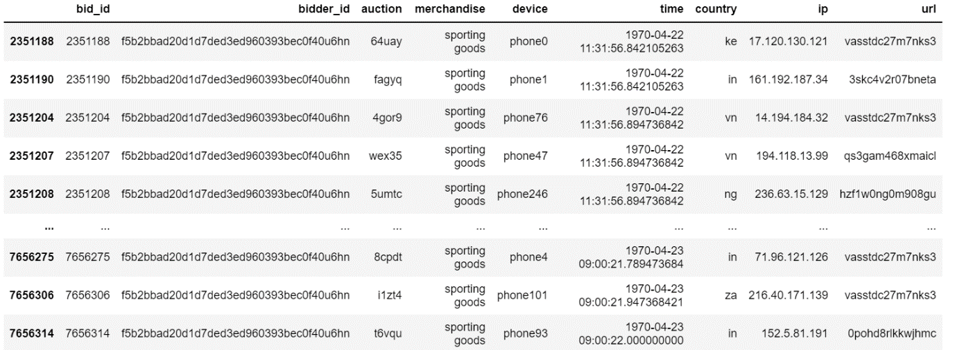

**Analyzing the top bidder shows that the bid from the same bidder-id came from multiple countries,**

**multiple IPs and URLs were used.**

**This points to the bids being computer-generated.**

**Exploratory Data Analysis**

The number of bids made by the top 20 bidders in 2 days. The top bidder made more than 500,000 (5 lakh) bids

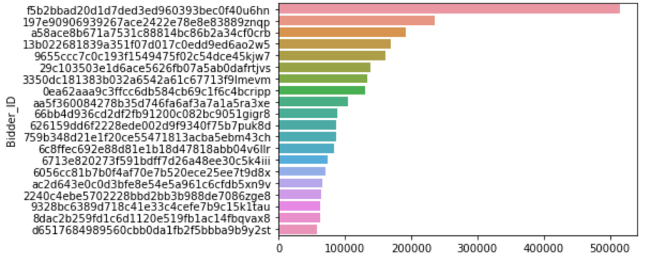

**This chart shows the number of bids made by the top 20 bidders in 2 days. The top bidder made more than 500,000 (5 lakh) bids**

**Proposed Solution**

* Validate biometric data like mouse movements, mobile swipe, and accelerometer data to distinguish bots from real users
* Enforce Google’s reCAPTCHA on traffic
* Mandate visitors to enter membership number, email address, valid IDs
* Pre-queue Bots together with humans eliminate early arrival advantage
* Eliminates hitting the web page milliseconds after the start of the sale.
* High concentration of visitors using the same IP address alerts bots are at play
* Allow unique IP addresses to enter